Steps install hadoop using Ambari and HDP distribution:

1. Launch four instances, I am using RHEL- 6.5 AMI for this procedure.
2. SSH to all the instances using Putty.
3. Run the following commands in all the nodes to avoid warnings later:

**echo never >> /sys/kernel/mm/redhat_transparent_hugepage/enabled**

Use below command on the nodes who has error rpm_check_debug vs depsolve.

**yum -y install libkadm5**

Use the below command to check the similar packages and remove duplicate packages otherwise it will give an error while installing the services.

**yum check**

**yum remove “Package name”**

1. Switch off Iptables, SElinux and switch on NTP protocol using below commands on all the nodes.

**service iptables stop**

**chkconfig iptables off**

**chkconfig ntpd on**

**service ntpd start**

**vi /etc/selinux/config**

Change the setting of the SELINUX=disabled

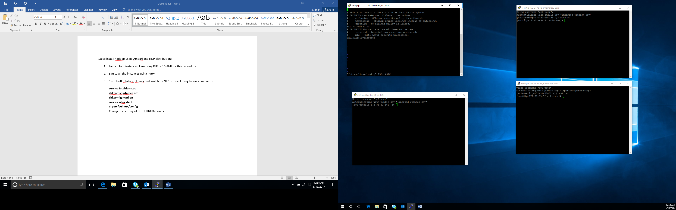

1. Now download the ambari-repository on all the nodes:

**wget -nv** [**http://public-repo-1.hortonworks.com/ambari/centos6/2.x/updates/2.5.1.0/ambari.repo -O /etc/yum.repos.d/ambari.repo**](http://public-repo-1.hortonworks.com/ambari/centos6/2.x/updates/2.5.1.0/ambari.repo%20-O%20/etc/yum.repos.d/ambari.repo)

1. Now install the ambari-server on the master node:

**yum -y install ambari-server**

1. Now install the ambari-agent on all the nodes:

**yum -y install ambari-agent**

1. Now get the full hostname of the master and add to the ambari-agent conf file.

**hostname –f**

**vi /etc/ambari-agent/conf/ambari-agent.ini**

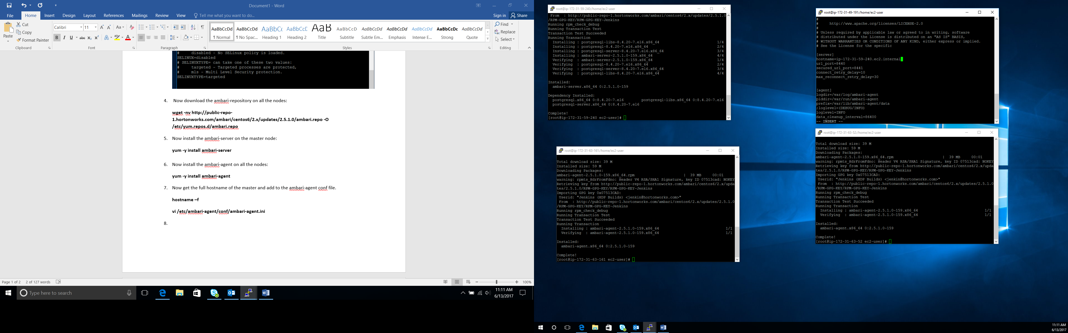

1. Now set up the ambari-server on the namenode. Use the below command and keep on pressing enter:

**ambari-server setup**

1. Now start the ambari-server:

**service ambari-server start**

**chkconfig ambari-server on**

1. Start the ambari-agent using below commands on all the nodes:

**chkconfig ambari-agent on**

**service ambari-agent start**

1. Now the open the ambari-server interface using the public ip address of the master node and 8080 port number.